ATACseq Analysis
General linux commands:
- “cd” will change the directory to wherever you want to go
- “ls” will list all the files/directories in the current directory that you’re in
- “pwd” will show you the entire file path for the directory you’re currently in
- “cntrl c” ends any command that is in process
- “ls -l” give u more info about a file and file size
- “rm” deletes files
- “cp” copy
- “vim” to go into a script/or view a script
- “cd ..” is to go backwards (out of 1 directory)
- “df -h” is to find the statistics of the server (useful when you think there is no space. Check ‘data’ category)
- “clear” will clear the screen
- cp <from path> <to path>
- mv <from path> <to path>
- “mkdir” will make a directory
- “rm -r” remove directory. ONLY USE ON erroneous STARtmp files

Script Editor: (press “esc”) first
- “G” to go to bottom
- “gg” to go to top
- “ZZ” to exit vim and save and quit
- Shift “I” how you change/edit the script
- Esc-button – exits the edit mode
- “:q!” exit vim without saving

Before Starting (only need to do the first time):
- Download the PEM key (get it from someone who has it and store it in a folder (if you want)).

Login on AWS:
- Login on AWS
- Sign in as a root user with the following login:
Username:
cferguson@health.ucsd.edu
Password:
OKMbhuTFC47$&
- Click on EC2
- Go to Instances (running)

Entering the Instance
- Open terminal on your computer.
- On terminal, change the directory to wherever the PEM key is:
  - cd [DRAG AND DROP FOLDER W/KEY]
  - hit enter
- In the next line, enter “ ssh -i ./210323.pem ubuntu@ec2….com ”
  - Copy the “ec2…” address on AWS.
  - The ec2 address will change after every time someone starts and stops the instance
  - After the “@” is where you paste the new/public ec2 address.
  - Change according to the ec2 line above, copy up to com.
  - Select “yes” to continue connecting.
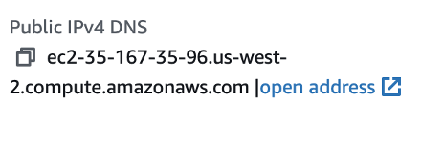

STEP 1: Import fastq files into the instance
- To import files into the instance, you have to be logged out of the instance
  - To logout type “logout”
- For MOUSE FILES: The import command is: “ scp -r -i ./210323.pem ‘fastq file’ ubuntu@ec2-35-88-77-234.us-west-2.compute.amazonaws.com:/home/ubuntu/rnaseq/mouse/fastqs/ “ slash = important
- For HUMAN FILES: The import command is: “ scp -r -i ./210323.pem ‘fastq file’ ubuntu@ec2-35-88-77-234.us-west-2.compute.amazonaws.com:/home/ubuntu/rnaseq/human/fastqs/ “ slash = important
- Once done, log back into the instance and check that the files are in the right location.

Challana troubleshooting
- Found the atacseq environment in /miniconda3/envs/
- Created QC directory in ~/atacseq/mouse/
  - To QC - fastqc 240403* -o ~/atacseq/mouse/QC

In ~/
~/atac-example/hindbrain_forebrain/config$ vim hindbrain_forebrain-template.yaml
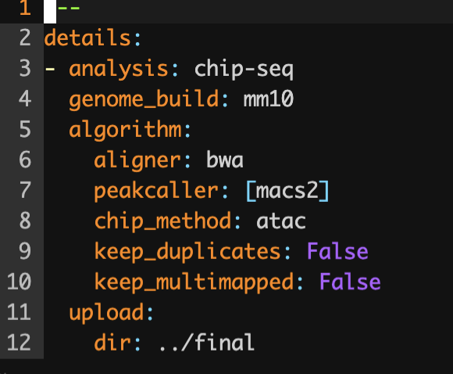
- Looks like bwa aligner is used

Looks like bcbiotx tool is used
https://bcbio-nextgen.readthedocs.io/en/stable/contents/atac.html
More extensive detailing:
https://bcbio-nextgen.readthedocs.io/en/latest/contents/configuration.html
- Made new yaml atac-CT-testing.yaml where I just added files: [in_pair_1.fq, in_pair_2.fq] because we have paired end data
- Made new csv file replicating hindbrain_forebrain but for this test data
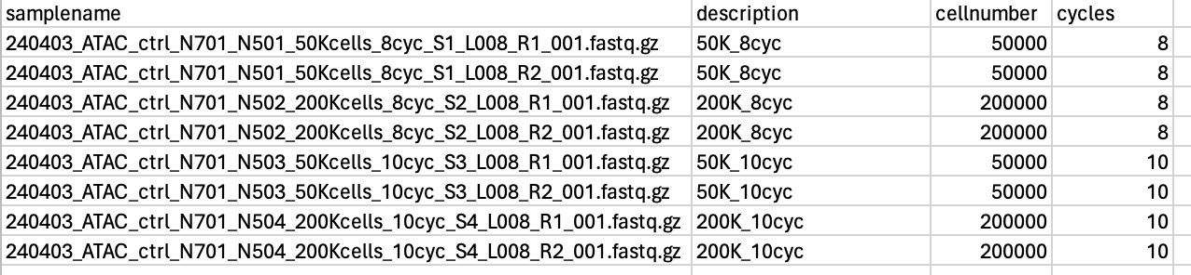
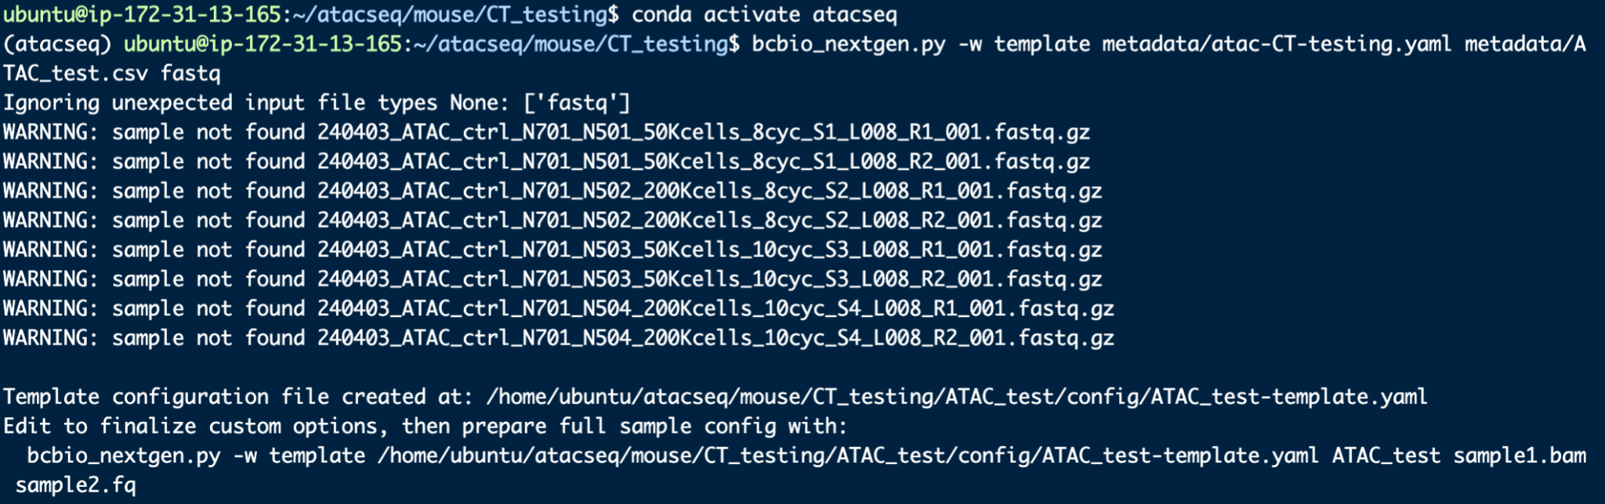
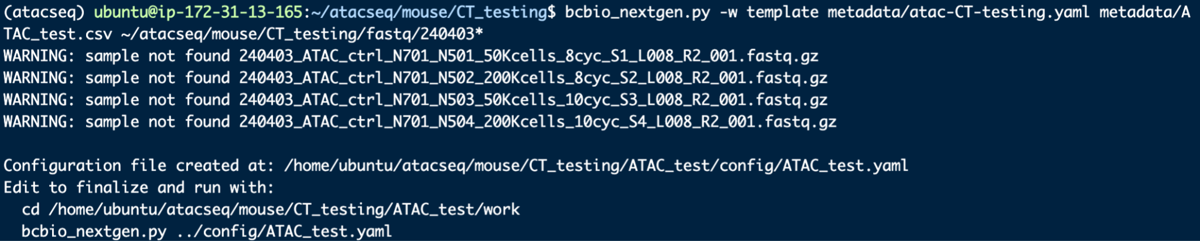
In /data/rs_256/workflow
- MACS2, SEACR output files

